Smart Wearables & Clothing Industry Newsletter – June 2025

Welcome to the latest edition of our Smart Wearables & Clothing Industry Newsletter. In this issue, we cover the current landscape of the industry, highlight major recent announcements (from smart shoes to smart fibers and AI wearables), and spotlight a new competitor’s smart fiber launch that challenges Zava’s own technology.

Industry Landscape: Trends & Consumer Insights
- Market Growth & Expansion: The wearable technology market is booming, with over half a billion wearable devices shipped globally in 2024. The smart clothing segment alone is estimated at $5.16 billion in 2024 and projected to grow at 26% CAGR through 2030. This growth is driven by cross-industry adoption – from sports and fitness to healthcare and fashion – as wearable tech becomes more ingrained in daily life.
- Health & Wellness at the Core: Health and fitness remain the prime focus for wearables. The COVID-19 pandemic underscored the value of real-time health monitoring, leading to a surge in devices that track biometrics. Today’s wearables act as personal health assistants – from smartwatches and rings monitoring heart rate and sleep, to shirts that capture biometric data. A societal push for healthy lifestyles and real-time bio-feedback is propelling adoption of devices and smart apparel that can monitor vital signs, posture, and activity levels. Users are increasingly relying on wearables to nudge healthier choices and improve well-being.
- Smart Clothing & IoT Integration: Smart clothing is emerging from novelty to reality, integrating electronics directly into textiles. We now have shirts with ECG sensors, shoes with step and calorie trackers, and jackets with built-in climate control[3]. Advances in textile sensors and microcontrollers allow garments to continuously monitor movement and vitals. Crucially, these high-tech clothes are part of the broader Internet of Things (IoT) – syncing with smartphones and smart home systems for a seamless experience. For example, workout shirts can transmit live data to fitness apps, and smart shoes might trigger home IoT devices (imagine your shoes telling your coffee maker to start when you finish a morning run). This ecosystem of interconnected wearables amplifies their utility and appeal.

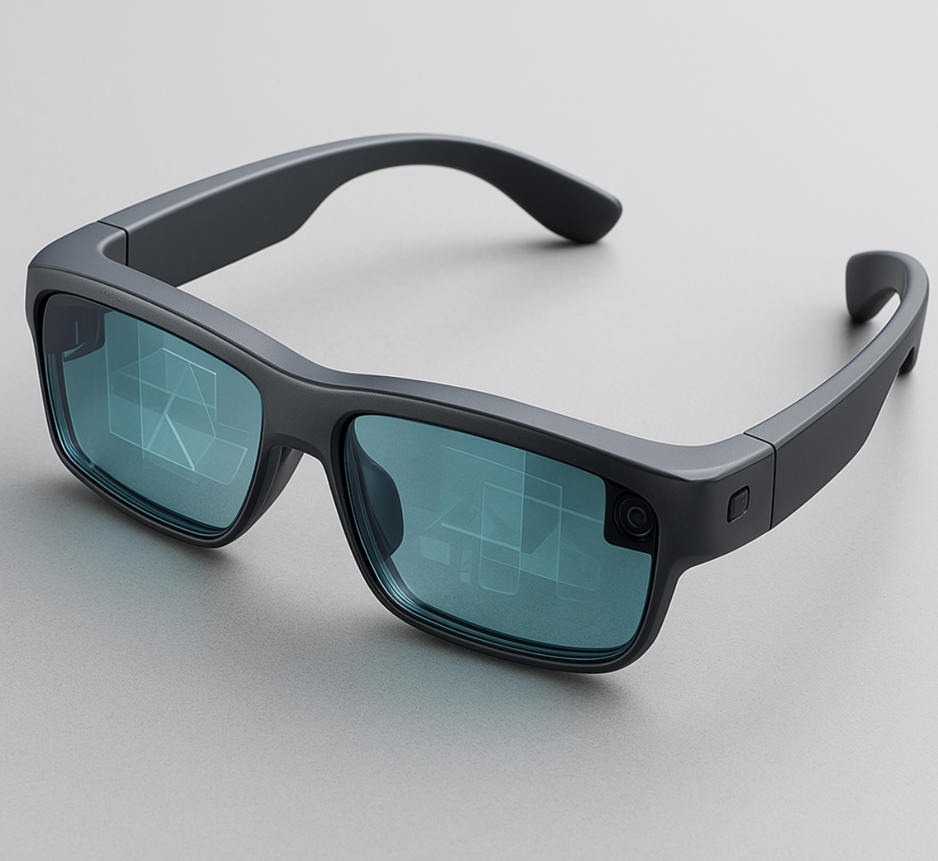
- AI and Advanced Tech Everywhere: Wearables are getting smarter and more sophisticated thanks to AI and new form factors. Artificial intelligence integration in wearables enables more personalized and predictive features. Fitness trackers now analyze your patterns and offer tailored coaching plans, while voice-assistant AI in earbuds and watches provides hands-free convenience. Emerging form factors like Augmented Reality (AR) glasses are gaining traction, overlaying digital info onto our view of the world. Once futuristic, AR eyewear is becoming practical for navigation, training, and assistive applications, heralding a new frontier in wearables. Additionally, technical leaps in battery efficiency (even solar and kinetic energy charging) are addressing one of wearables’ historic pain points – giving devices longer life and truly untethered mobility.
- Consumer Adoption & Trust: As wearables go mainstream, consumer behavior is evolving. There’s a greater variety of price points now, with more affordable options targeting budget-conscious buyers[3]. This diversification means wearables are accessible to more people than ever, not just tech enthusiasts. In parallel, companies are placing a greater emphasis on data privacy and security to earn user trust. Modern wearables handle sensitive health and location data, so makers are implementing stronger encryption, anonymized data processing, and user controls. Consumers are increasingly aware of privacy, and the industry is responding – making security a selling point. Comfort and style have improved too, with devices made to look like jewelry or regular apparel rather than obvious gadgets. All of these factors are lowering barriers and integrating wearables more naturally into consumers’ lifestyles.

Challenges and Opportunities

Key Challenges
- Data Privacy & Security: With wearables collecting a wealth of personal health and location data, privacy concerns are a major challenge. Manufacturers must ensure robust data encryption, secure cloud handling, and user consent controls to prevent misuse of sensitive information[3]. Regulatory compliance (e.g., GDPR, HIPAA) is increasingly important as health data flows through consumer devices. Earning and keeping user trust through transparency and strong security practices is an ongoing hurdle for the industry.
- Battery Life & Durability: Advanced wearables pack many sensors and wireless functions that can drain batteries quickly. Limited battery life has long been a pain point for users. Durability is also tested as electronics meet the real world – devices and smart garments must withstand water, sweat, bends, and washes. Improving battery longevity and ruggedizing wearables without adding bulk remains a key technical challenge.
- Integration & Interoperability: Wearable tech spans many platforms (different phone OS, smart home systems, etc.). Ensuring smooth integration and interoperability is vital but challenging. Consumers expect their smartwatch, fitness band, smart shoes, and smart clothing to all sync up conveniently. This requires common standards and partnerships between tech companies, apparel makers, and software providers. Fragmentation in the ecosystem can frustrate users. The industry is working toward more universal compatibility (for example, standardizing data formats for health metrics), but it’s a work in progress.
- User Comfort & Adoption: Achieving the right balance between functionality and comfort is not trivial. Wearables that are obtrusive, unfashionable, or hard to use will turn off consumers. User adoption can stall if devices are seen as gimmicky or inconvenient. Companies face the challenge of design – making sensors and batteries virtually unnoticeable in clothing, and interfaces intuitive for all age groups. They also need to clearly demonstrate value: devices should solve real consumer pain points (like improving fitness, safety, or convenience) to avoid ending up in a drawer after the novelty wears off.

Growth Opportunities
- Healthcare & Wellness Applications: Healthcare is the biggest growth opportunity for wearables. From fitness and wellness tracking to managing chronic conditions, smart wearables are poised to transform personal health management. There is rising interest in medical-grade wearables like smart patches, biosensor shirts, and health-monitoring jewelry to detect issues early and enable remote patient monitoring[4]. An aging population worldwide creates demand for wearables that assist the elderly – such as fall-detection shoes or heart-monitoring undershirts – opening new markets for smart apparel. Insurers and employers are also exploring providing wearables to improve wellness, which could significantly expand adoption.
- Sports & Fitness Performance: The sports industry continues to embrace wearables, offering huge potential for innovation. Athletes and fitness enthusiasts are using smart clothing and shoes to gain data-driven training insights. From smart running shoes that analyze gait, to sensor-laden suits for professional sports teams, performance wearables can give competitive advantages. This segment is willing to invest in premium technology for measurable improvements. Additionally, as everyday consumers adopt more active lifestyles, the demand for advanced fitness trackers and smart activewear is set to grow steadily. Companies that deliver accuracy and actionable feedback in their wearable products stand to gain a dedicated customer base.
- Fashion & Lifestyle Integration: Technology and fashion are converging, presenting opportunities to create stylish smart wearables that people genuinely enjoy wearing. Smart rings, bracelets, and apparel that double as fashion statements can tap into the huge lifestyle market. Personalization is key – e.g., smart clothes that change color or shape based on user preference (as recently demonstrated by some startups) show how tech can offer novelty and personal expression. There’s also interest in sustainable smart textiles – such as energy-harvesting fabrics or clothes that adjust to temperature – which align with eco-conscious consumer trends. Brands that blend form with function can unlock new revenue streams in the apparel and luxury sectors.
- Enterprise & Workplace Wearables: Beyond consumers, wearables in the workplace is an emerging opportunity. Companies are deploying wearable tech for employee safety, productivity, and training. For instance, smart glasses can provide hands-free instructions to technicians in the field, smart helmets and vests can monitor industrial workers’ vitals and environment for safety, and wearable badges can improve office security and efficiency. The enterprise market often values reliability and custom solutions – a space where specialized wearable platforms could thrive. As organizations seek digital transformation of their operations, enterprise wearables could become a standard tool across industries like manufacturing, logistics, healthcare, and retail.

Major Announcements & Innovations
The past year has seen significant developments in smart wearables and clothing, as companies big and small push the envelope. Here are some of the major announcements making waves in the industry:
- Color-Changing Smart Shirt (June 2024): A Silicon Valley startup introduced a high-tech smart shirt that can automatically change its color via a mobile app. This novel apparel uses electrically reactive pigments in the fabric, allowing the wearer to switch colors and patterns on demand. The product, launched on a major e-commerce platform in India, highlights how fashion and tech are merging – offering personalization at the tap of an app. It also points to a future where your outfit’s look could be as dynamic as your digital wallpaper.
- Self-Adjusting Smart Shoes (June 2024): In the footwear arena, a global sportswear leader unveiled its most advanced smart running shoes capable of auto-adjusting their cushioning in real time. Embedded sensors and motors in the shoe detect the runner’s impact and speed, then adjust the sole’s firmness on the fly to optimize comfort and support. This innovation, essentially an AI coach in your sneakers, means casual runners and athletes can get adaptive performance without changing shoes or settings manually. The launch demonstrates how leading athletic brands are infusing AI and robotics into footwear to enhance athletic performance and everyday comfort.

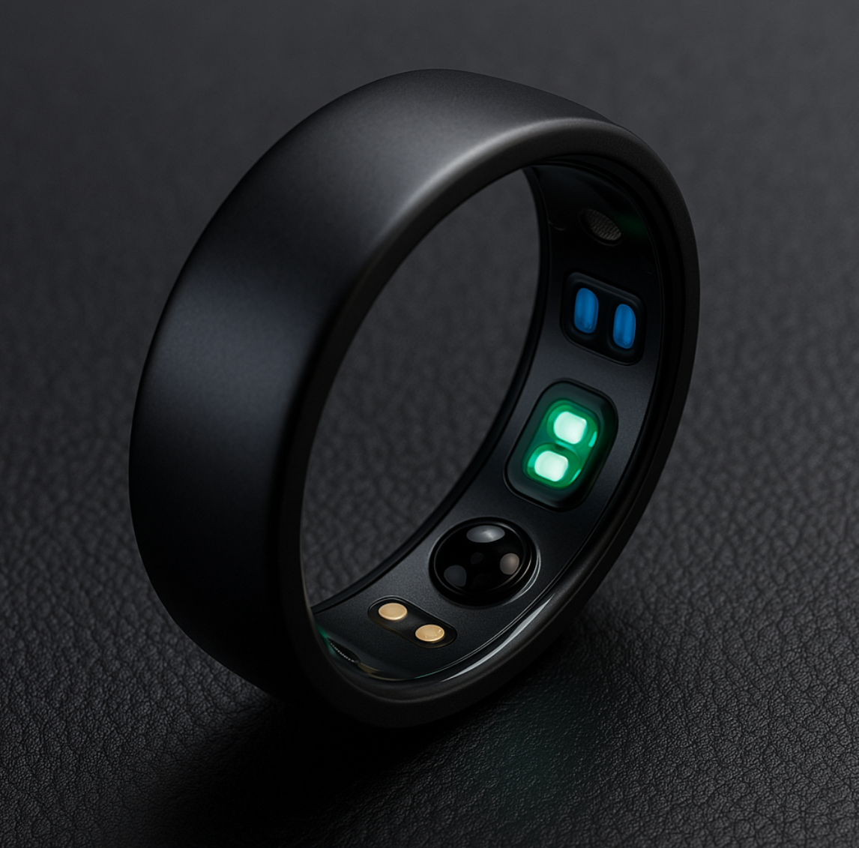

AI-Powered Wellness Ring (Jan 2024): Wearables are getting smaller and smarter – case in point: the Evie smart ring made headlines as an upcoming health tech accessory specifically designed for women. This sleek ring packs sensors for sleep quality, blood oxygen, heart rate, and more. Uniquely, it employs an AI that correlates biometric data with menstrual cycle logs, mood, and activity levels to provide personalized wellness insights. For example, it might note that on days where the wearer takes more steps, her reported mood is better. With an open-ring design for comfort (addressing finger size changes), the Evie ring showcases innovation in AI-driven personal health assistants that don’t even look like gadgets. It’s slated to launch at an affordable price, indicating how rapidly such advanced capabilities are becoming accessible.

Competitor Spotlight: New Rival Smart Fiber Emerges
NextWeave Unveils “NanoFlex” Smart Fiber: In a surprising move, a new competitor,
NextWeave has announced a cutting-edge smart fiber called NanoFlex Fiber that directly challenges Zava’s flagship smart fiber technology. This announcement has the industry abuzz, as NextWeave’s innovation could heat up the smart textile race.
NanoFlex Fiber is a next-generation conductive thread designed to be woven into clothing and wearables – similar in intent to Zava’s smart fiber, but with some notable claims. According to NextWeave’s press release, NanoFlex Fiber offers unprecedented flexibility and durability: it can be bent or stretched repeatedly while maintaining full sensing capability, and is rated to withstand over 50 machine wash cycles without performance loss. The company also touts built-in micro-sensors and AI processing directly on the fiber. In practical terms, a garment made with NanoFlex could monitor your heart rate, temperature, and movement in real time, performing on-fiber data analysis to give instant feedback or alerts to the wearer.
Perhaps the most striking feature – and a clear attempt to one-up everyone – is NanoFlex’s self-charging capability. NextWeave says the fiber can harvest energy from the wearer’s movements (kinetic energy) and ambient solar light to power its sensors. If true, this would greatly reduce the need for external batteries or frequent charging, addressing a common pain point in wearable tech[2]. “NanoFlex Fiber is a game-changer for smart textiles, aiming to make wearable tech virtually invisible, comfortable, and self-sufficient,” the company stated in its announcement.
By combining sensing, processing, and power harvesting in a single thread, NextWeave’s NanoFlex pushes the envelope of what smart fabrics can do. Industry observers note that this directly competes with Zava’s own smart fiber, which set the bar for integrated sensor-fibers in apparel. While Zava’s fiber is well-regarded for its conductivity and accuracy, the NanoFlex claims hint at possible advantages in longevity and energy independence. It remains to be seen if the real-world performance of NanoFlex Fiber lives up to the hype, but its entry is undeniably a bold challenge to our product line.

The smart wearables and clothing sector is more dynamic than ever. We’re witnessing a convergence of tech, health, and fashion, with innovations arriving from startups and tech giants alike. Zava’s leadership in smart fiber is being challenged, but healthy competition will spur faster advancement across the industry. Looking ahead, we can expect wearables to become even more integrated into everyday life – from what we wear to how we manage our health and activities – all while becoming more personalized, reliable, and invisible in use. It’s an exciting time to be in the smart wearable space, and we’ll continue to keep you updated on the trends and breakthroughs shaping our wearable future.

